Pedigree of Taishi Go Soga Goruen
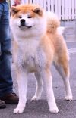  Taishi Go Soga Goruen  Red and White  Japan  2013 | 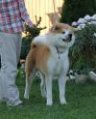  Tenshin Go Shirai  Red and White  Japan  2012 | 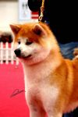  Sagenta Go Shirai  Red and White  Japan  2011 | Hayatemaru Go Ooshiro  Red and White  Japan  2010
Yumemeguri Go Shirai
Red and White
Japan
2009
 |  | 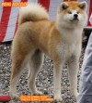  Beni Aoi Go Shirai  Red and White  Japan  2011 | WINNER Akita Cup 2013  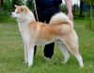  Ginji Go Shirai  Red and White  Japan  2010
Shion Go Musashi Aiwa
Red and White
Japan
2008
 | Musouka Go Shirai  Red and White  Japan  2011 | WINNER Akita Cup 2013  Ginji Go Shirai  Red and White  Japan  2010 | 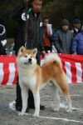  Awa Unjou Go Kisarazu Nomura  Red and White  Japan  2008
 | Musouka Go Shirai  Red and White  Japan  2011 |  | MEIYOSHO WINNER 2011  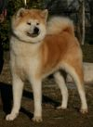  Sara Go Shirai  Red and White  Japan  2006
 | Musouka Go Shirai  Red and White  Japan  2011 | 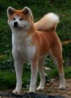  Sumida No Sakura Go Ooshiro  Red and White  Japan  2010 | Japan. Ch  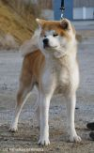  Yuushou Go Musashi Aiwa  Red and White  Japan  2008
 | Musouka Go Shirai  Red and White  Japan  2011 |  | 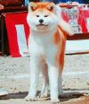  Miki Go Isehara Futami  Red and White  Japan  2005

